|  |  |  |  |  |  |
| --- | --- | --- | --- | --- | --- |
| Date | 6-Dec-22 | | | Tester Name | Richard Belanger |
| Environment | Penfax - Test | | | Login used | TEST2 |
| Operating System | Windows | Version: | Update: | | |
| Software Used | Edge | Version: | Update: | | |
| Not Applicable | Version: | Update: | | |
| Release version | 22.4.1 | | | | |
| Title | M13.06 Single member eligible-not eligible to retire | | | | |
| Test Type | Regression | | | | |
| Test Scenario | Calculate benefits for Deferred member death | | | | |
|  |  | | | | |
| Expected Results | Member will be Terminated after Death and payment produced | | | | |
| Pass/Fail | Pass | | | JIRA# | N/A |

Describe your steps with screenshots:

Member is Single/Deferred>passed away September 30/22

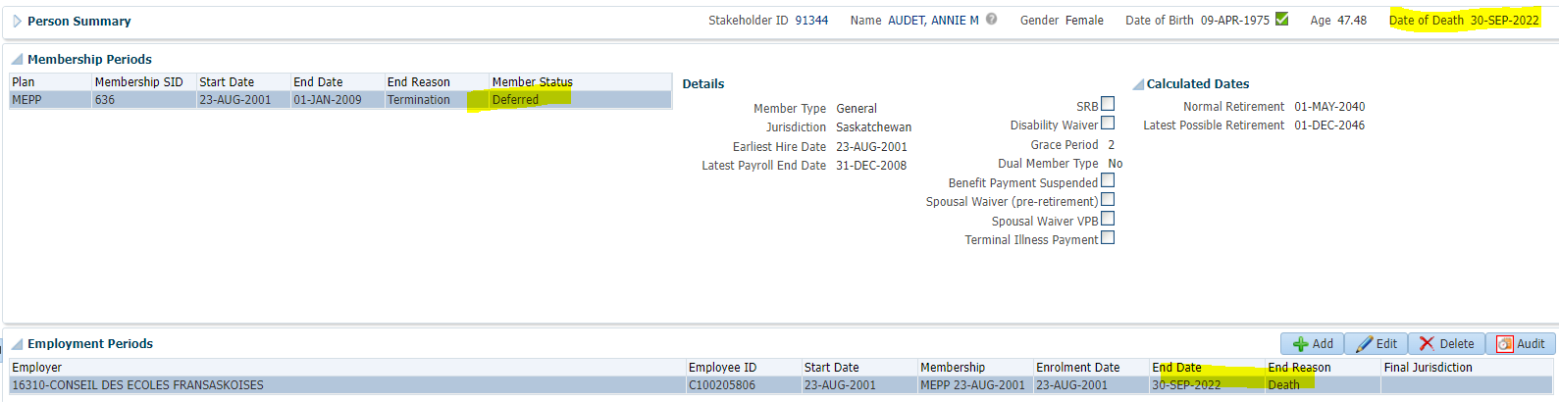

Benefit Calc.

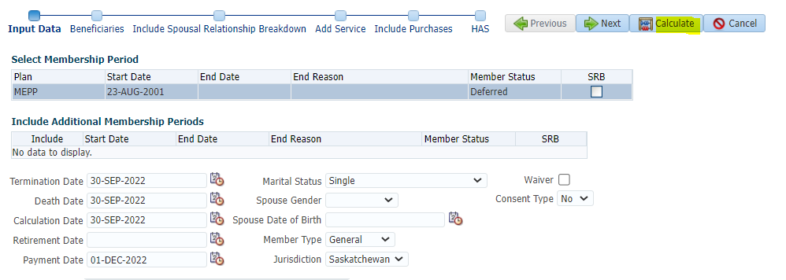

Processed

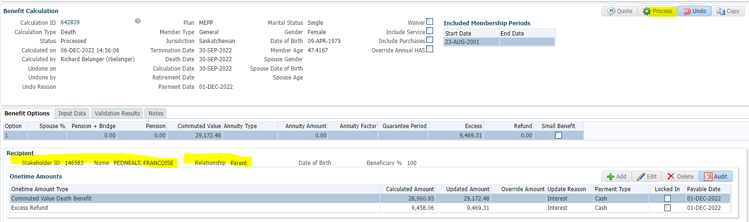

Benefit Selection>Next

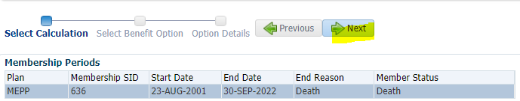

Add Payment Date>Next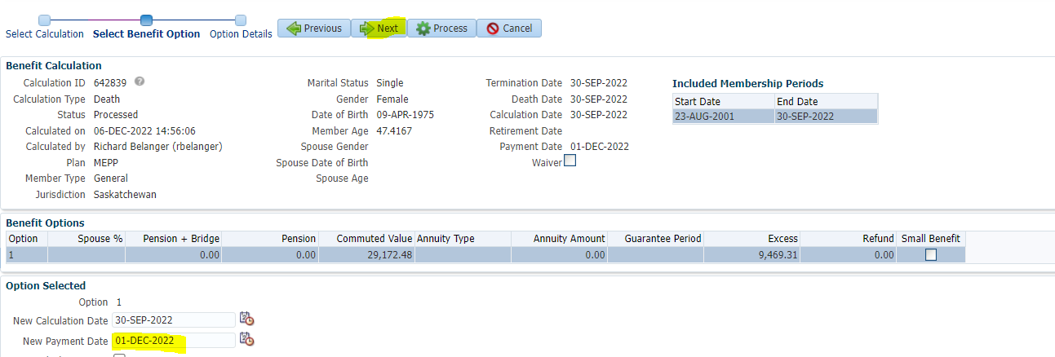

Add Payment Instructions>Process

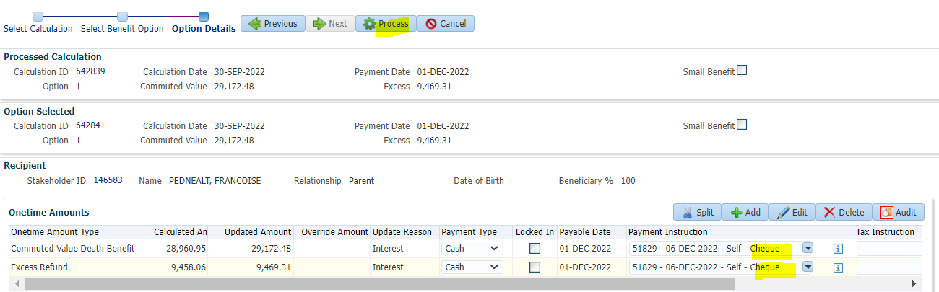

To Benefit Recipient

Submit for Approval>Submit>Authorize

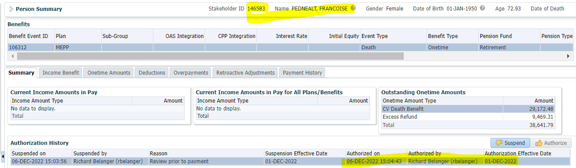

After Running Payments

Payment History

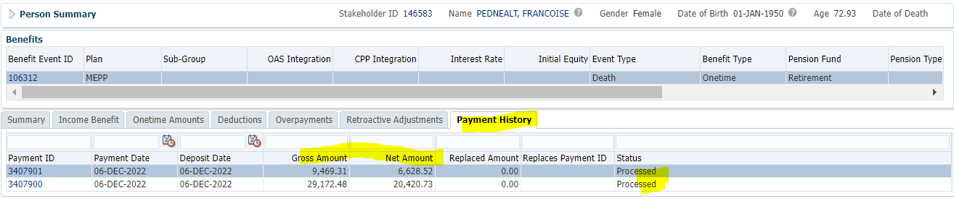

Tax Rates

0.00-4,999.99 = 10%

5,000.00- 14,999.99 = 20%

15,000.00+ = 30%

Tax taken from Total amount

9469.31 + 29172.48 = 38,641.79;

38,641.79 x 30% = 11,592.54;

38,641.79 - 11,592.54 = $27,049.25; 6628.52 + 20420.73 = **$38,641.79**